TUẦN 5
TIẾT 2:
UNIT 2: MAKING ARRANGEMENTS
LANGUAGE FOCUS

- STRUCTURES:
- Talking about intention with “be going to”: (nói về ý định với “be going to)
- Form:
(+) : S + be + going to + V_{bare}...
(-) : S + be not + going to + V_{bare}...

- Adverbs of place: (Trạng từ chỉ nơi chốn)
- Here (ở đây), there (ở kia), outside (ở bên ngoài), inside (ở bên trong), upstairs (ở tầng trên), downstairs (ở tầng dưới),…

- TEXTBOOK CONTENTS:
LANGUAGE FOCUS
1. Work with a partner. Say what the people are going to do. Follow the example sentence.
Example: Nga has a movie ticket.
⟶ She s going to see a movie.

a) Quang and Nam bought new fishing rods yesterday.
b) Trang’s mother gave her a new novel this morning and she has no homework today.
c) Van has a lot of homework in Math and she is going to have Math at school tomorrow.
d) Mr. Hoang likes action movies very much and there’s an interesting action movie on TV tonight.
e) Hien’s friend invited her to his birthday party.
2. a) Copy the questionnaire in your exercise book. Add three more activities to the list. Then complete the "you" column with checks (✓) and crosses (X).
What are you going to do on the weekend?
Are you going to... | YOU | YOUR PARTNER
see a movie?
play sports?
meet your friends?
help your parents?
do your homework?
watch TV?
b) Now ask your partner what he or she is going to do. Complete the ‘your partner’ column of the questionnaire.
3. Complete the speech bubbles. Use each adverb in the box once.
Ba is playing hide and seek with his cousin, Tuan.
outside inside there here upstairs downstairs

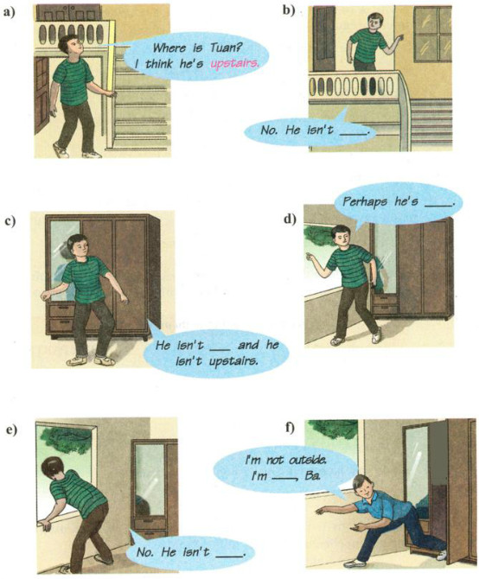

LƯU Ý :

- Phần A.từ vựng (VOCABULARY) bao gồm 2 phần :
+ Từ mới đã được giáo viên giảng dạy trong các clip đính kèm .
+ Ôn lại các từ quan trọng trong bài học ( nếu học sinh có quên cách đọc các từ này có thể tra cứu bằng từ điển online trên GOOGLE hoặc hỏi trực tiếp giáo viên bộ môn)

- Phần B : là nội dung sách giáo khoa (TEXTBOOK CONTENTS) dành cho những em chưa tiếp cận được sách giáo khoa giấy, điện tử .

